Reflection(week 4):-

In week 4 lab, firstly we installed an express package by typing: npm install express-save in vs code terminal then we learned about how to use Node JS Express to create REST API. Got an idea about the GET and POST method to create REST API URLs with or without parameters. Use of body parser whenever we use the form to submit data. I have been clear to read the parameter using req. param and req. paramsid. Then we started coding as guided in the lab tutorial and all the code that I have performed are in the GitHub link and all the output I have mentioned below.

Exercise 1:-

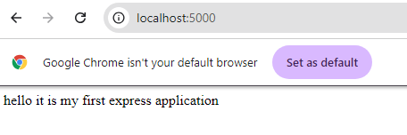

Exercise 2:-

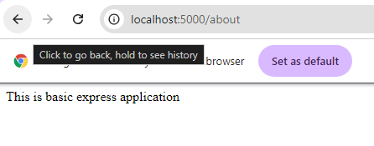

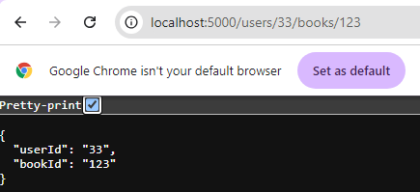

Exercise 3:-

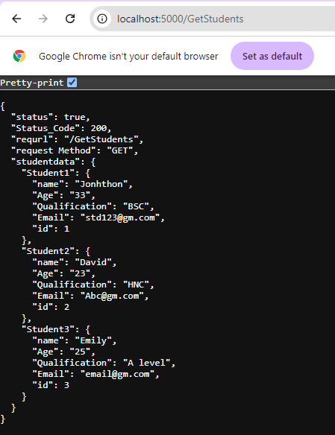

Localhost:5000/ GetStudentid/1

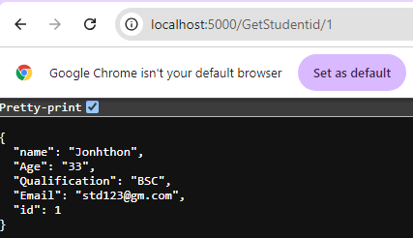

Localhost:5000/ GetStudentid/2

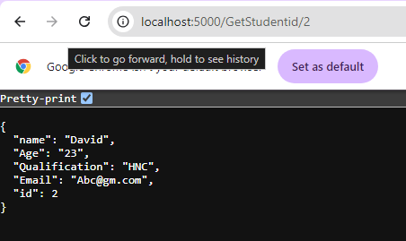

Localhost:5000/ GetStudentid/3

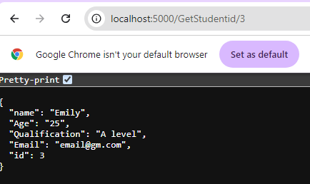

Localhost:5000/ GetStudentid/4

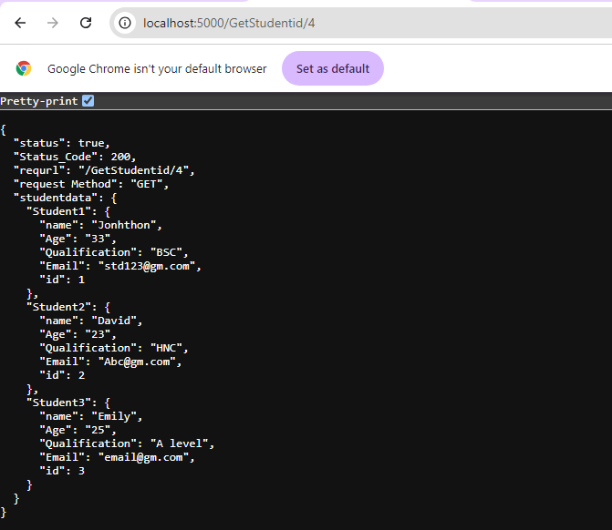

Localhost:5000/ studentinfo

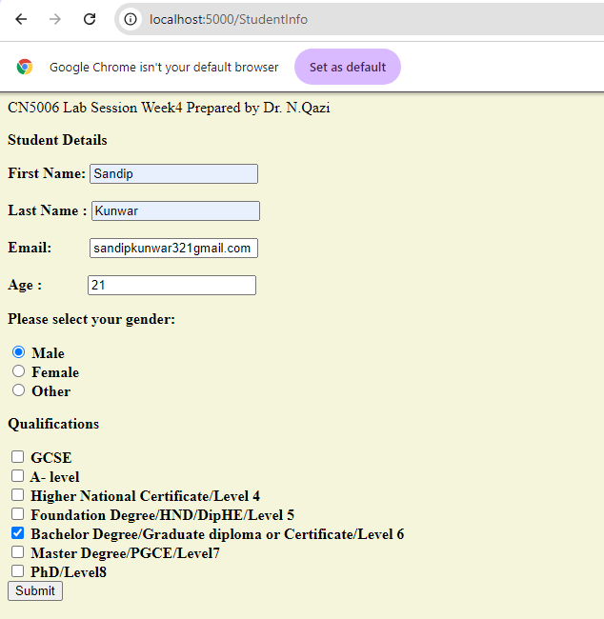

Submit this form by clicking the submit button. You may see the following output based on what you entered.

